Development of a Simple R Package (aLBI) for the Estimation of Stock Status from the Length Frequency Data

Ataher Aliª, Mitu Ranjan Sarker^{b}, Mohammed Shahidul Alamª*

ªDepartment of Fisheries, University of Chittagong, Chattogram- 4331, Bangladesh; ataher.cu.ms@gmail.com; alamms@cu.ac.bd
^{b}Institute of Marine Sciences, University of Chittagong, Chattogram- 4331, Bangladesh; mitusarkerims@cu.ac.bd

*Correspondence author e-mail: alamms@cu.ac.bd

ABSTRACT
Stock assessment is a difficult task for sustainable fisheries management especially when population and fisheries data are limited. This study aims to develop an accessible and tested R package (aLBI) that applies length frequency and provides functions for estimating length-based indicators (LBIs) to measure stock health. The primary objective is to streamline the calculation and visualization of the estimated metrics for a clear understanding. The package includes two main functions, i.e., FishPar (for calculating key LBIs such as maximum length (L_{max}), asymptotic length (L∞), length at sexual maturity (L_{mat}), optimum length (L_{opt}), L_{opt}±10% (L_{opt_p10}, L_{opt_m10}) and percentages of fish at maturity (P_{mat}), optimum length (P_{opt}), and mega spawners (P_{mega}) with confidence intervals) and FishSS for evaluating stock biomass status. This study also evaluated the performance of the package by applying length frequency data from Sperata aor collected from Kaptai Lake. The findings with a calculated optimum bin size three (cm) demonstrate its utility in producing acceptable stock assessments, with mean estimates for L_{max}, L∞, L_{mat}, and L_{opt} at 78.01 cm, 82.12 cm, 43.73 cm, and 47.03 cm, respectively, as well as respective confidence intervals. Besides, percentages of sexually mature fish, optimum length, and mega spawners are 2.04%, 2.38%, and 0.35%, against targets of 100%, 100%, and 20% respectively. By integrating advanced statistical methods and user-friendly interfaces, aLBI enables effective monitoring of fish populations and informed decision-making. Tested on various bin size (1 to 5 cm) with the collected length frequency data S. aor, the package performed consistently. Future recommendations include expanding functionality to cover more species and integrating additional biological parameters for enhanced stock assessments. Continued collaboration with the fisheries science community will ensure aLBI remains a cutting-edge tool for sustainable fisheries practices.

Key words: R package development, stock assessment, aLBI, length-based indicators (LBIs), target biomass, limit biomass, Kaptai Lake.

INTRODUCTION
Effective fisheries management has become a global concern due to the rapid increase in over-exploited fish stocks worldwide. Addressing this issue requires the development and implementation of effective management policies to ensure the sustainability and recovery of these stocks. (Hilborn & Walters, 1992; FAO, 2020). Robust and well tested fish stock assessment plays critical roles in providing reliable estimates of different reference points, which form the basis for informed policy-making. Scientifically sound stock assessments provide the information that are necessary to implement conservation measures such as fishing quotas, effort controls, and gear modifications. These measures are essential for balancing resource exploitation with conservation, reducing fish stock depletion rates, and preventing the collapse of fisheries (Pilling et al., 2008; Punt et al., 2016; Punt et al., 2020). Thus, knowledge about the population status is critical for effective management (Alam et al., 2021). However, traditional stock assessment methods require extensive and high-quality data, such as time-series data on catch and effort, size composition, and life history parameters. As a result, these methods are often difficult to apply to most fish stocks, particularly in developing countries, where data limitations are common. Moreover, the lack of resources and political will further compounds these challenges, hindering effective fisheries management in these regions. (Hilborn and Walters, 1992; Scott et al., 2016). Given this situation, several stock assessment methods have been developed for data-limited fisheries. Among these methods, some require yearly landing data and life history parameters (i.e., natural mortality, maximum age, age at maturity; Martell and Froese, 2013; Thorson and Cope, 2015; Prince et al., 2015; Zhou et al., 2017; Free et al., 2017; Canales et al., 2018), while other require length-frequency data in cohort analysis models (Hordyk et al., 2014; Nelson, 2017; Froese et al., 2018; Prince et al., 2015; Rudd and Thorson, 2018; Ault et al., 2019). Collecting length-frequency data is often more straightforward and cost-effective than gathering of landing data, and the resultant data tend to be more reliable (Chong et al., 2020; Pilling et al., 2008; Hordyk et al., 2015; Mildenberger et al., 2017; Froese et al., 2018).
Thus, length-based stock evaluation methods provide a good and typically more practical option (Pauly & Morgan, 1987). Using length frequency data, these techniques estimate significant population parameters like patterns of recruitment, growth rates, mortality rates due from natural causes and fishing, and so on (Sparre & Venema, 1998; Gelman & Shalizi 2013). One consistent approach to find length frequency information is to look at fish landings or market samples. While lengths can provide valuable insights for stock assessment, this is true only under certain applications; for example, the Length-Based Spawning Potential Ratio (LBSPR) method does not estimate recruitment, growth, or natural mortality, as these are assumed values. Nevertheless, the application of length frequency data-based stock assessment models has become increasingly popular, particularly in areas with low financial and technological resources (Gayanilo & Sparre et al., 2005; Hoggarth et al., 2006).
To address data limitations in fish stock assessment, scientists have developed various methods based on length-frequency data (Mildenberger et al., 2017; Hordyk et al., 2015; Froese et al., 2018; Froese, 2004). These methods have gained popularity due to the simplicity of collecting length data, which is readily available from landing centers and fish markets. Among these approaches, the length-based indicators proposed by Froese (2004) stand out for their straightforward methodology and outputs that are easily understood by all stakeholders, from fishermen to policymakers. This method evaluates stock health by determining whether a stock is experiencing growth or recruitment overfishing, and whether the spawning biomass is at or below reference points. In extreme data-poor situations, this approach remains an effective and practical tool for fisheries management if the methods properly interpret selectivity, promoting the sustainability of fish stocks (Froese, 2004; Cope & Punt, 2009). By simplifying the evaluation of stock sustainability, these metrics serve as practical tools for both scientific research and fisheries management in data-limited settings. Therefore, this study aims to develop a simple, robust, and user-friendly R package, “aLBI,” to estimate Froese’s length-based indicators (LBIs)—such as the proportion of mature individuals (P_{mat}), optimally sized fish (P_{opt}), and large, older fish (P_{mega})—directly from length-frequency data. The package also incorporates a decision-tree approach proposed by Cope and Punt (2009) to evaluate current stock biomass status relative to biological reference points, accounting for gear selectivity. The automated procedures of the package make it an easy-to-use and valuable tool for fisheries researchers and managers, especially in data-limited contexts.

METHODOLOGY

Analytical Approach and Description of the aLBI Tool

Installation of the package
The package (aLBI) is accessible on GitHub repository (for latest update) and also available on CRAN (https://cran.r-project.org/web/packages/aLBI/index.html). For detailed installation instructions, troubleshooting tips, and additional information, users can refer to the vignettes (https://cran.r-project.org/web/packages/aLBI/vignettes/Introduction.html).

Main functions of aLBI package
Table 1. Main Functions of aLBI R package
Functions | Descriptions | Usage | Arguments
FrequencyTable | This function creates a frequency distribution table for fish length data | FrequencyTable(data, method, bin_width, Lmax) | data: A numeric vector of fish lengths.  bin_width: Optional. A numeric value specifying the bin width for class intervals, if left NULL, the bin width is automatically calculated using Wang et al. (2020) optimum bin size (OBS) formula.  L_{max}: Optional. The maximum length of fish. If left NULL then automatically calculate the frequency table with the observed maximum length of the provided data.
FishPar | Calculates various length-based indicators for fish stock assessment using length frequency data and bootstrap resampling. | FishPar(data, resample, progress) | data: A data frame containing two columns: Length and Frequency.  resample: An integer indicating the number of bootstraps resamples.  progress: A logical value indicating whether to display progress.  L∞: A numeric value for the asymptotic length (optional).  Linf_sd: A numeric value for the standard deviation of random variation added to Linf (default: 0.5). Only used if L∞ is provided by users.  L_{mat}: A numeric value for the length at maturity (optional).  Lmat_sd A numeric value for the standard deviation of random variation added to Lmat (default: 0.5). Only used if Lmat is provided by users.
FishSS | Assesses the stock status based on parameters calculated by the FishPar function | FishSS(data, LM_ratio, P_{obj}, P_{mat}, P_{opt}) | data: A data frame containing the necessary columns for stock status calculation. (Cope & Punt, 2009)  LM_ratio: A numeric value representing the ratio of L_{mat} and L_{opt}.  P_{obj}: A numeric value representing the sum of P_{mat}, P_{opt} and P_{mega}.  P_{mat}: A numeric value representing the percentage of mature fish.  P_{opt}: A numeric value representing the percentage of optimally sized fish.
The Frequency Table function generates the frequency table as well as provides a data frame containing the upper length class and their corresponding frequencies. With this frequency table the FishPar function facilitates the analysis by estimating key biological parameters, such as the maximum length (L_{max}), asymptotic length (L∞), and length at maturity (L_{mat}), using Monte Carlo and bootstrap methods (Table 1). It ensures data integrity by validating input data and generating robust confidence intervals for parameter estimates. Additionally, it provides insightful visualizations to help interpret the results, making it a valuable tool for researchers and fishery managers. In addition, the FishPar function also calculate particular indicators such as L_{mat}/L_{opt} ratio (LM_ratio) and sum of P_{mat} P_{opt} P_{mega} (P_{obj}) to ascertain the stock status. Analyzing these indicators help one to choose suitable columns from the input data to create important stock metrics such as Limit Spawning Biomass (LSB25) and Target Spawning Biomass (TSB40) (Table 1) by FishSS function. This dual-function strategy improves our knowledge of fish population dynamics, therefore helping to guide the development of sensible management plans and fisheries policies.

Analytical procedures

Calculating frequency table by FrequencyTable function
Frequency distribution table was constructed using the following formula of optimum bin size (OBS) recommended by Wang et al. (2020), facilitate by the Frequency Table function of aLBI package.
$Optimum Bin Size (OBS) =(0.23*({Lmax}^{0.6})$............... (1)
L_{max} = Maximum length

Estimating growth parameters by FishPar function

Key length parameters for S. aor, including maximum length (L_{max}), asymptotic length (L∞), length at maturity (L_{mat}), and optimum length (L_{opt}), were estimated using the FishPar function within the aLBI package. L_{max} was defined as the maximum observed length in the dataset unless derived from a user-specified L∞. When not provided, L∞ was calculated according to following equation proposed by Pauly (1984):

$L_{∞}=\frac{L_{max}}{0.95}$……………............................. (2)
The
L_{mat} and L_{opt} for S. aor were estimated using empirical equations from Froese & Binohlan (2000) within the FishPar function of the aLBI package. L_{mat} was calculated as:

logLmat=0.8979logL∞-0.0782……………. (3)
Where, L∞ is the asymptotic length. L_{opt} was then derived from L_{mat} as:
$\log\left(L_{opt}\right)=1.053\left(\log\left(L_{mat}\right)\right)-0.0565$……………. (4)
The FishPar function allowed user-specified values for L∞, and L_{mat} with default standard deviations (Linf_sd = 0.5 and Lmat_sd = 0.5) or user-defined variability to reflect uncertainties from sources like FishBase or empirical studies. When parameters were estimated from data, a default standard deviation of 0.015 was applied to log-transformed L_{mat} and L_{opt} to account for variability. The inclusion of these parameters was a direct response to the need to explore sensitivity in parameter estimates, ensuring the model could simulate realistic variability in growth and maturity metrics.

Monte Carlo Simulation for Parameter Uncertainty
To quantify uncertainty in length parameters (L∞, L_{max} L_{mat}, L_{opt}), Monte Carlo simulations were performed using the FishPar function, generating 1,000 simulated datasets. L_{max}_samples were drawn from a normal distribution centered on the observed L_{max} with a standard deviation of 1 cm, constrained to 90–110% of L_{max} for biological plausibility. L∞ samples were derived as L_{max}_samples / 0.95 (Pauly, 1984) or from user-specified L∞ with added noise (normal distribution, mean = 0, sd = Linf_sd = 0.5 cm). L_{mat} and L_{opt} samples were calculated using empirical equations from Froese & Binohlan (2000) with added noise (standard deviation = 0.015 for log-transformed values). Results were stored in a parameter_estimates matrix, with means and 95% confidence intervals computed using the 2.5th and 97.5th percentiles via R’s stats package (version 4.5.1). This approach ensured robust parameter estimates by accounting for inherent biological variability, as recommended by (Thorson et al., 2014a).

Estimating Length-Based Indicators (LBIs) by FishPar function
In order to evaluate the stock status in relation to exploitation and prevent excessive fishing that could harm development and recruitment, Froese (2004) suggested three length-based indicators (LBIs) known as P_{mat}, P_{opt}, and P_{mega}.
- The first indicator P_{mat}, can be defined as the proportion of mature fish in the catch, and it represents the concept of “let them spawn!” The percentage of fish in the capture that have a length larger than the length at sexual maturity (L_{mat}) was determined using the following formula proposed by Froese (2004):
$P_{mat}=\sum_{L_{mat}}^{L_{max}}{P_{L}}$………………... (5)
Where, P_{L} is the percentage of fish in the catch composition with a length interval of L.
- Indicator two P_{opt}, defined as the percentage of fish caught at their optimal length (L_{opt}), which is the length that maximizes the yield and revenue.. P_{opt} was calculated by following formula:

logLopt=1.053logLmat-0.0565
$P_{opt}=\sum_{{0.9L}_{opt}}^{{1.1L}_{opt}}{P_{L}}$…………… (6)
- The P_{mega}, defined as the percentage of old and larger fish (mega = mega spawner) in the catch composition. The metric is calculated as the proportion of mature fish in the catch that exceed the optimal length by 10%. The following equation was used to estimate P_{mega}:
$P_{mega}=\sum_{{1.1L}_{opt}}^{L_{max}}{P_{L}}$…………… (7)

Non-Parametric Bootstrap for LBI Uncertainty
Uncertainty in LBIs was quantified using a non-parametric bootstrap approach within the FishPar function. Length-frequency data were expanded into individual observations based on frequencies, and 1,000 bootstrap samples were generated by resampling with replacement, preserving the total frequency. For each sample, P_{mat}, P_{opt}, and P_{mega} were calculated using length ranges derived from Monte Carlo simulations. The 2.5th and 97.5th percentiles of the resulting distributions were used to compute 95% CIs, with bounds capped at 0% and 100% to ensure biological plausibility. This method, implemented using R’s sample and quantile functions, provided robust estimates of indicator variability, complementing the Monte Carlo approach for length parameters (Efron, 1992).

Stock spawning biomass (SB) evaluation
FishSS function evaluates the stock status using a decision table (CPdata) demonstrated by Cope and Punt (2009), which is readily available within the aLBI package based on the input parameters (LM_ratio, P_{mat}, P_{opt}, P_{mega}) derived from FishPar function. The function classified stock health relative to limit (LSB25, 25% of unfished spawning biomass) and target (TSB40, 40% of unfished spawning biomass) reference points to determine whether the stock was overfished or sustainable. P_{mat} aimed to ensure all fish reproduce at least once before capture (target: 100%), P_{opt} targeted capture within ±10% of the optimum length (0.9L_{opt} to 1.1L_{opt}, target: 100%), and P_{mega} indicated a healthy stock structure at 30–40% or potential overexploitation below 20% (Froese, 2004). These metrics, integrated into the decision table, provided robust insights for fisheries management.

Evaluating the robustness of the aLBI package
To evaluate the robustness of the aLBI package under varying bin sizes, the length frequency data were rearranged using the FrequencyTable function of the aLBI package with bin sizes of 1 to 5 cm, in addition to the base model with a bin size of 3 cm. Examining bin structure is crucial because it influences the resolution of length-frequency distributions, thereby affecting the estimation of length parameters (e.g., L_{max}, L∞, L_{mat}, and L_{opt}) and the accuracy of derived length-based indicators (LBIs), while potentially masking biological patterns or introducing bias if bins are too coarse or too fine. The uncertainty in length-based indicators (LBIs) (P_{mat}, P_{opt}, and P_{mega}) was propagated from the uncertainty in key length parameters such as length at maturity (L_{mat}), optimal length (L_{opt}), and maximum length (L_{max}). The uncertainty in these length parameters was estimated through a bootstrapping approach, which resampled the length data 1,000 times to generate confidence intervals for each parameter. The LBIs for each bin size were then estimated using the outputs of the bootstrapping procedure. Thus, the inherent uncertainties in the length data were addressed to produce robust estimates of the fishery. To test the significant difference among the length parameters and LBI estimates, one-way ANOVA and Turkey’s HSD test were also employed.

Assumptions and Validation
The methodology assumed stock equilibrium (stable growth, mortality, and recruitment), fisheries-representative sampling, and consistent fishing pressure, as required for LBIs (Froese, 2004). These assumptions were supported by collecting data over eight months from multiple sites. Sensitivity analysis across bin sizes and uncertainty quantification via Monte Carlo and bootstrap methods confirmed the robustness of the estimates, aligning with best practices in fisheries research (Froese et al., 2016).

Application Context

Study area
This study focuses on the collection of length frequency data of S. aor from Kaptai Lake, located in the Chattogram district of Bangladesh. The lake lies in the southeast part of Bangladesh, within the coordinates of latitude 22°22' to 23°18'N and longitude 92°00' to 92°26'E (Figure 1). Kaptai Lake, the largest man-made freshwater lake in the country with a water area of 68,800 hectares which is 1.46% of the total inland open water bodies (DoF, 2023), is a vital resource for local fisheries and communities. The lake interconnects several upazilas, including Rangamati Sadar, Langadu, Nannerchar, Jurachari, Kaptai, and Belaichari. It is fed by the Karnaphuli, Chengi, Mayani, Kassalong, and Rinkhyong rivers. Fishing activities in Kaptai Lake play a crucial role in the livelihoods of local communities and contribute significantly to Bangladesh's inland fisheries production (Galib et al., 2018; Suman et al., 2021; Shalehin et al., 2022). As the largest artificial lake in the country, Kaptai Lake provides an expansive fishing ground, supporting both commercial and subsistence fishing practices (Rahman et al., 2024). The lake is home to a wide variety of freshwater fish species, including native species like catfish (Sperata aor, Mystus spp.) and carps (Labeo rohita, Cirrhinus mrigala), as well as introduced species like tilapia (Oreochromis spp.) (Lima et al., 2023).
Kaptai lake fisheries multi-species and multi-gear in nature (Rahman et al., 2024) where fishing methods employed in range from traditional techniques such as cast nets, gill nets, traps, and seine nets to modern fishing gear for commercial operations. Seasonal fishing activities, heavily influenced by monsoon patterns, are vital for meeting the local demand for protein and generating income. However, overfishing, habitat degradation, and water level fluctuations pose challenges to the sustainability of these activities. Efforts to manage Kaptai Lake’s fisheries include community-based management and government interventions to ensure stock sustainability. Notably, seasonal fishing bans (April to July) and the establishment of conservation zones are key strategies implemented to maintain fish biodiversity and regulate fishing activities. These approaches aim to balance ecological preservation with the socio-economic needs of local communities. (Pearce et al., 2002; Suman et al., 2021; Shalehin et al., 2022)
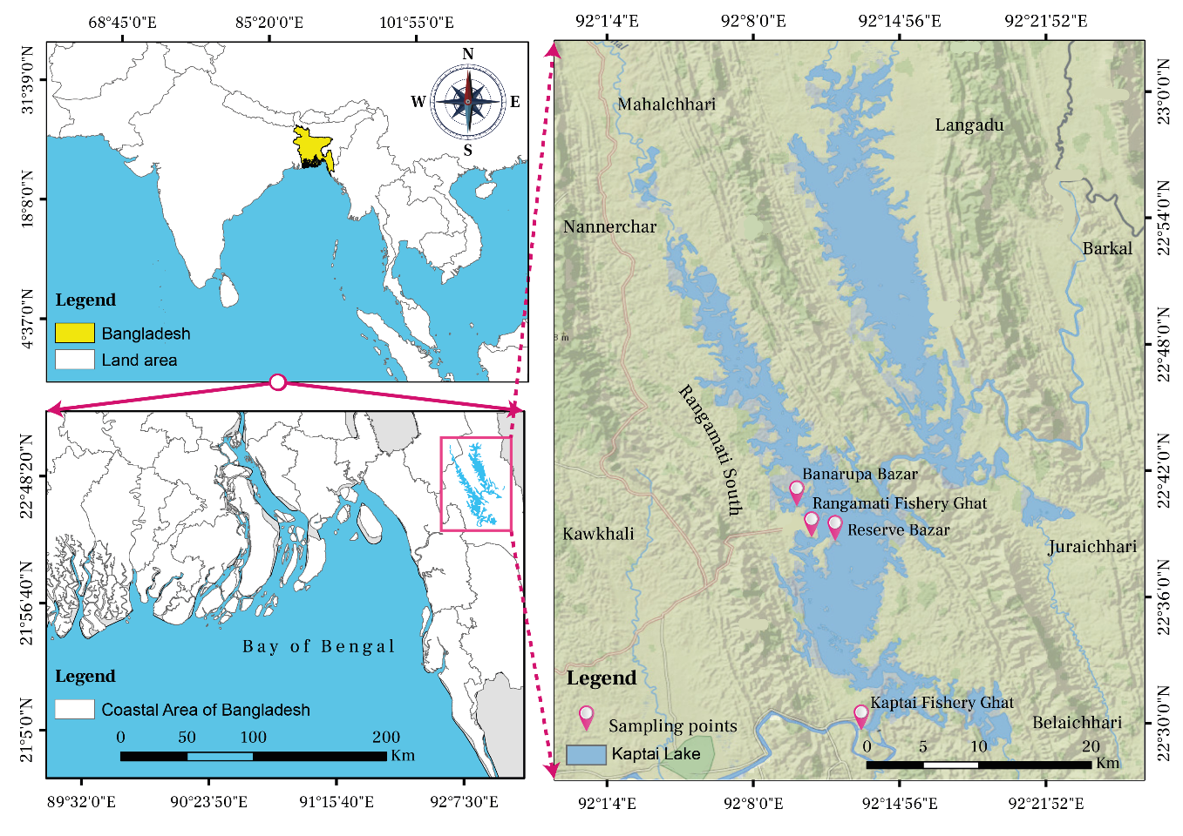
Figure 1: Map showing the sampling points of the study

Target Species: Sperata aor
The Sperata aor (Hamilton, 1822), commonly known as the long-whiskered catfish, is an important species within the Bagridae family, widely distributed across freshwater systems in South Asia, including the river basins of the Ganges, Brahmaputra, and Indus. In Bangladesh, this species is notably prevalent in Kaptai Lake, an artificial reservoir created in 1966 by damming the Karnaphuli River, is an important habitat for almost all indigenous fish species in Bangladesh. Recognized as a hotspot for biodiversity, this lake plays a critical role in providing food, nutrition, and livelihoods for thousands of local people (Hossain et al., 2012). S. aor significantly contributes to the annual total landings and is one of the major fish species harvested from the lake. (Shalehin et al., 2022). However, the species is experiencing increasing fishing pressure driven by the rising demand for indigenous fish at both local and national levels. Despite its importance, no comprehensive study has been conducted to assess the stock status of S. aor in Kaptai Lake. Studies on other species in the lake have revealed signs of overexploitation (Bashar et al., 2021; Khatun et al., 2023; Mia et al., 2024), raising concerns about similar trends for S. aor. Given its ecological and economic significance (Rana et al., 2024), evaluating the current stock status of S. aor is imperative. Such an assessment is essential for developing effective conservation measures to ensure sustainable exploitation, maintain ecological balance, and preserve the biodiversity that supports the local economy.

Collection of length frequency data and processing
Four sampling stations (Figure 1): BFDC Fishery Ghat, Rangamati (22°38'55.22"N & 92°11'4.41"E); BFDC Fishery Ghat, Kaptai (22°29'51.12"N & 92°13'11.66"E); Banarupa Bazar (22°39'13.36"N & 92°10'44.15"E); and Reserve Bazar (22°39'16.26"N & 92°11'49.33"E) were selected for monthly length data collection from August 2022 to March 2023 (Figure 2). Due to the fishing ban between April and July, data were not collected in this period. In the landing stations, fisher gathers their catches in different pile. During the high landings, fishers were asked to mixed the pile properly and 10% of the well-mixed pile were collected for collecting the length data. Similarly, during the low landings, 30 – 100% fish were collected. Lengths of the fish were measured using a meter scale to the nearest 0.1 cm using a measuring scale and recorded in excel file in s single column to compiled into a two-column data frame (Length and Frequency) of different bin size using FrequencyTable function of aLBI package. Data quality was validated using FishPar function within the aLBI package, ensuring positive frequencies, a minimum sample size of 100 individuals, and at least three unique length classes. Warnings were issued for skewed distributions (e.g., >80% frequency in a single length class) to flag potential biases that could affect parameter estimation.
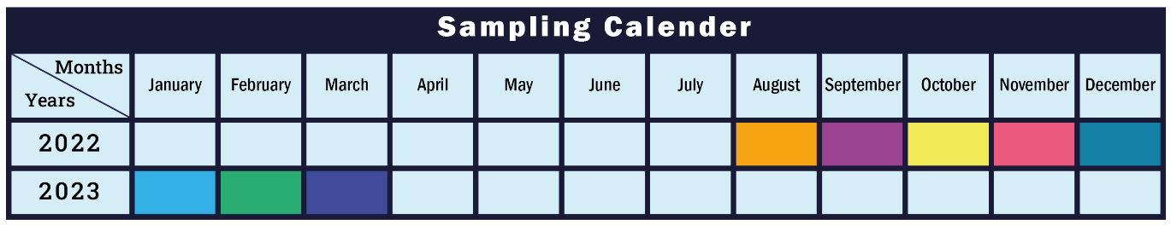
Figure 2: Sampling calendar of the study

RESUTS

Observed output of FishPar function
Length-frequency data of S. aor were input into the aLBI package to estimate parameters and visualize plots for understanding the stock status.

Frequency distribution plot
The total lengths (TL) of 1177 S. aor individuals, ranging from 9.5 to 75 cm were measured. A frequency table with an optimum class interval of 3 cm and a unimodal length frequency distribution plot (Figure 3) was produced by aLBI package. The observed frequencies represented by bars, revels the highest abundance of individuals within the length class of 27 cm (156 individuals) and followed by 30 cm (143 individuals), 21 cm (137 individuals), 24 cm, 18cm both with the same count (135 individuals), indicating these lengths are common among the sampled fish population.
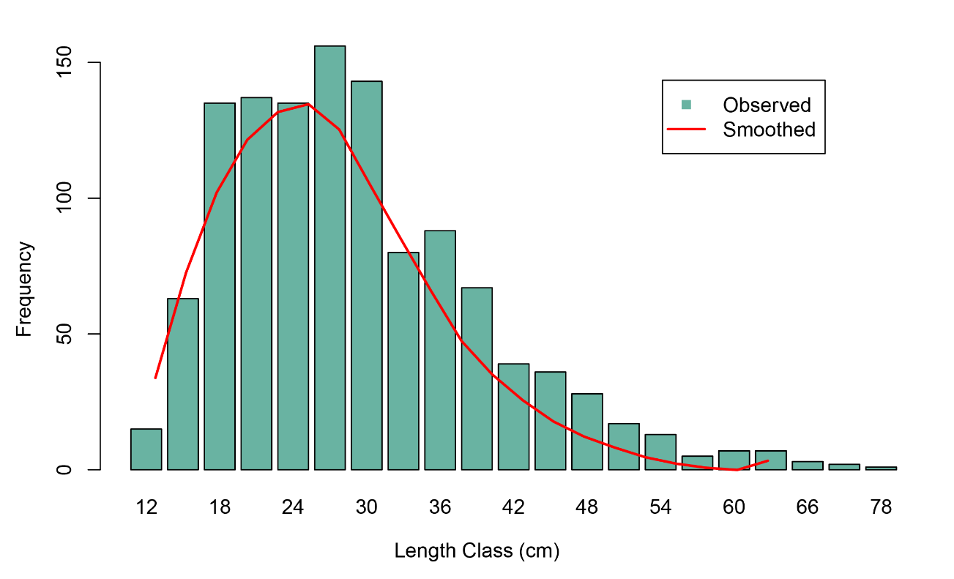
Figure 3: Plot showing the length frequency distribution of S. aor.
The red curve, representing the modeled frequency, aligns closely with the observed data, highlighting the accuracy of the applied smoothing approach. This curve is generated using a loess (locally estimated scatterplot smoothing) regression, to fit a smooth line to the histogram, enhancing visual interpretation of the length-frequency distribution. The plot was found to be heavily skewed towards right side, indicating good recruitment but also potential growth overfishing.

Estimating different length groups
The aLBI package produced a plot (Figure 4) for different length groups of S. aor. The length-based metrics provided a comprehensive understanding of the fish stock status. The plot depicts the mean maximum length (L_{max}) of 78.01 cm with a confidence interval (CI) 76.00 to 79.93 cm and asymptotic length (L∞) of 82.12 cm with a CI of 80.00 to 84.13 cm, indicating that the species has the potential to attain considerable sizes under optimal conditions and minimal fishing pressure. The mean length at sexual maturity (L_{mat}) of 43.73 cm with a CI 40.71 to 46.78 cm. The mean optimum length (L_{opt}) is 47.03 cm with a CI 42.49 cm to 51.61 cm. On the contrary, the estimated range for L_{mat}±10% of L_{opt} is 42.33 (with a CI 38.24 to 46.45) to 51.74 cm (with a CI 46.74 to 56.77) (Table 2), represents the ideal range which produces maximum biological yield.
In Figure 4, the upper bounds are consistently close to the medians, indicating narrow confidence intervals. This results from the low variation in the resampled length data and the large sample size, both of which lead to higher precision in the bootstrap estimates.
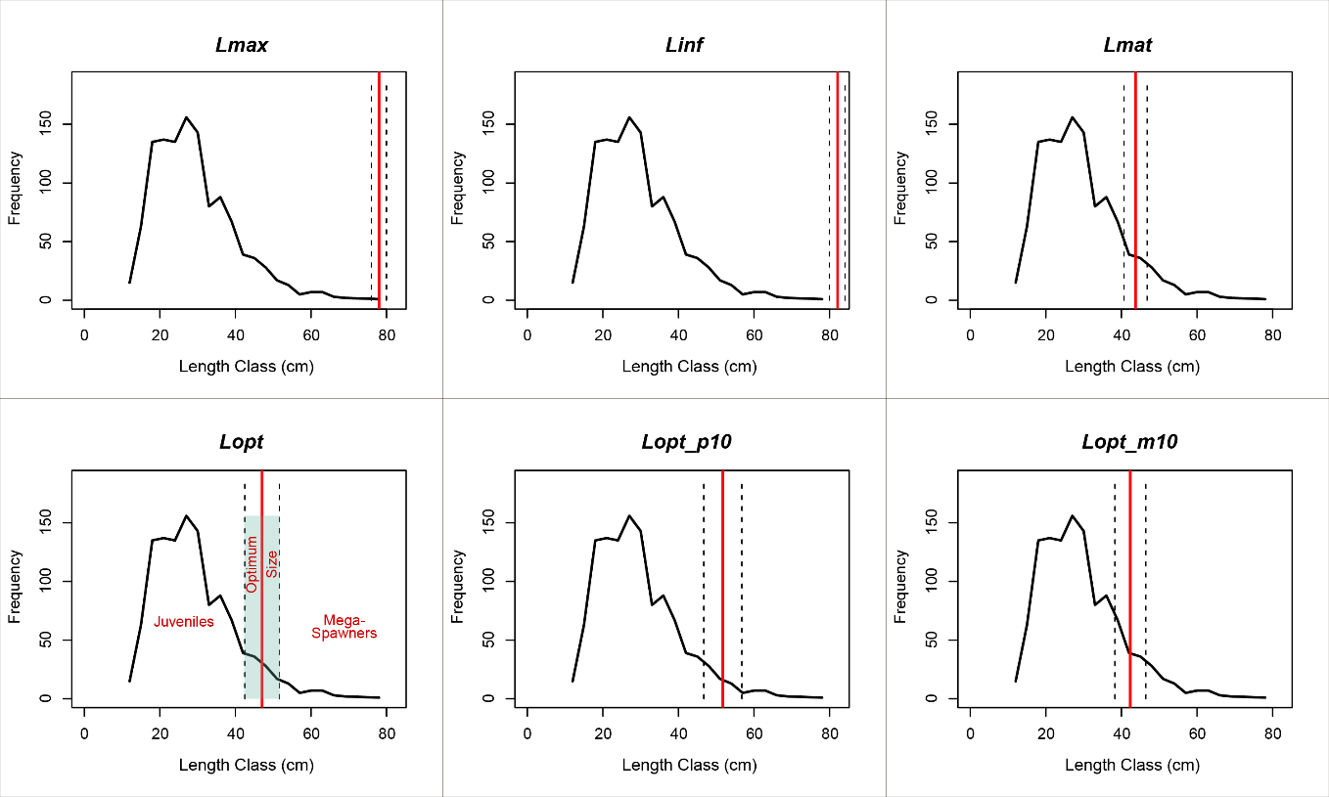
Figure 4: Plot showing the frequency line with different length parameters of Seperata aur. Solid red lines depict the mean estimates and dotted lines depicts the lower (LCI) and upper confidence intervals (UCI).

Estimated length-based indicators of S. aor and their respective confidence intervals are shown in the Table 2.
Table 2: Different length indicators of S. aor with 95% Confidence Intervals.
Indicators | Mean (cm) | LCI | UCI
L∞ | 82.12 | 80.00 | 84.13
L_{max} | 78.01 | 76.00 | 79.93
L_{mat} | 43.73 | 40.71 | 46.78
L_{opt} | 47.03 | 42.49 | 51.61
L_{opt_p10} | 51.74 | 46.74 | 56.77
L_{opt_m10} | 42.33 | 38.24 | 46.45
Note: LCI = Lower Confidence Interval; UCI = Upper Confidence Interval

Scenario produced with different bin size for length indicators
The boxplot (Figure 5) illustrates the consistency of the estimated length indicators (L∞, L_{mat}, L_{max}, L_{opt}, L_{opt_m10}, and L_{opt_p10}) across different bin sizes (1 to 5, with the base model bin size of 3 cm). Though no statistical difference in the metrics when using different length bins, there are some differences in the values were observed. The estimated values of L∞ and L_{max} exhibited moderate deviations from the base model, ranging from -2.53% to +1.27%, with the largest negative deviation at bin size 1cm (-2.53%) and positive deviation at bin size 5cm (+1.27%). L_{mat} and L_{opt} showed deviations of -2.13% to +1.19% and -2.45% to +1.25%, respectively, with bin size 1cm showing the greatest reduction and bin size 5cm the largest increase relative base model bin size. Parameters L_{opt_m10} and L_{opt_p10} followed similar patterns, with deviations from -2.46% to +1.25%. Statistical analysis using One-Way ANOVA and Tukey's post-hoc test confirmed that the differences in estimated length indicators across different bin sizes were not significant (p > 0.05), suggesting low overall sensitivity.

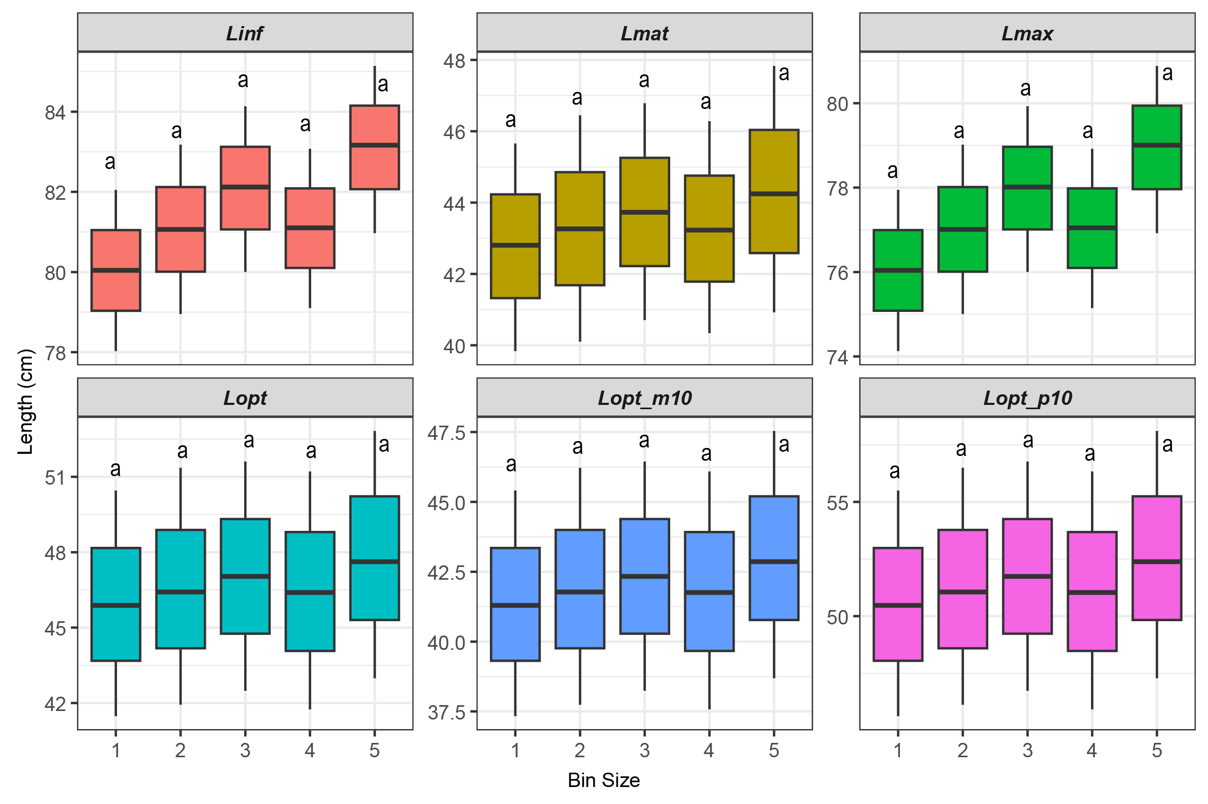
Figure 5: Distribution of length indicators with different bin size (base model bin size = 3 cm), represented with the mean, lower and upper confidence intervals. Shared letter (a) indicating no significant differences (p > 0.05) in the estimation of length indicators with different bin size based on one-way ANOVA and Tukey’s HSD.

Length-Based Indicators (LBIs)
The simple set of indicators (P_{mat}. P_{opt}, P_{mega}) proposed by Froese (2004), were estimated for the stock of Sperate aor (Table 3) reveal significant deviations from the target reference values. The percentage of sexually mature fish (P_{mat}) was 2.04% (0.88–3.58%), far below the target of 100%, indicating heavy exploitation of immature fish and reduced reproductive potential. Similarly, the percentage of optimally sized fish (P_{opt}) was 2.38% (0.87–5.80%), is also below the 100% target, reflecting insufficient numbers of fish reaching their full growth potential. The proportion of mega-spawners (P_{mega}), crucial for genetic diversity and population resilience, was only 0.35% (0.08–1.16%), compared to the target of 20%, highlighting that this fishery has already removed major portion of its larger individuals. The combined indicator (P_{obj}) was 4.77% (1.84–10.53%), further underscoring the stock's unsustainable status.

Table 3: Estimated length-based indicators (LBIs) with 95% Confidence Intervals
Indicators | Mean (%) | LCI | UCI
P_{mat} | 2.04 | 0.88 | 3.58
P_{opt} | 2.38 | 0.87 | 5.80
P_{mega} | 0.35 | 0.08 | 1.16
P_{obj} | 4.77 | 1.84 | 10.53

Scenario produced with different bin size for the aLBI indicators
The boxplot (Figure 6) illustrates the robustness of the method implemented in the aLBI package by producing consistent estimates of Froese sustainability indicators (P_{mat}, P_{opt}, P_{mega}) across varying bin sizes (1 to 5 cm, with a base model bin size of 3 cm). The propagated uncertainty from the length indicators (L_{mat,} L_{opt} and L_{max}) resulted in minor deviations from the base model, with P_{mat} ranging from -2.60% to +0.13%, P_{opt} from -3.25% to -0.4%, and P_{mega} from -1.07% to +1.53%. Statistical analysis using One-Way ANOVA and Tukey's post-hoc test confirmed that the differences in estimated length indicators across different bin sizes were not significant (p > 0.05), underscoring the method’s stability and low sensitivity to bin size variation. These findings suggest that the aLBI package provides reliable estimates for fisheries management, though the low Pmat value may warrant further validation against species-specific maturity data.

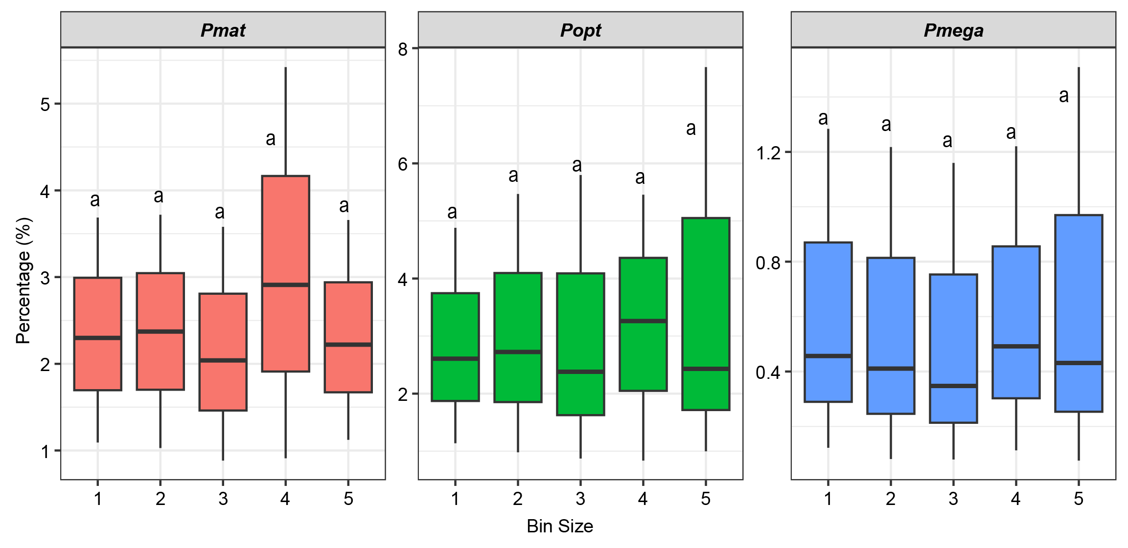
Figure 6: Distribution of LBIs with different bin size, represented with the mean, lower and upper confidence intervals. Shared letter (a) indicating no significant differences (p > 0.05) in the estimation of length indicators with different bin size based on one-way ANOVA and Tukey’s HSD.

Observed stock status of S. aor by FishSS function
FishSS function facilitate the evaluation of stock status by quantifying the decision tree process outlined by Cope and Punt (2009). The sum of the all the three proportions (P_{mat}, P_{opt}, P_{mega}), termed as P_{obj}, provides comprehensive information to distinguish the selectivity patterns. The FishSS function estimates two key reference points: i) TSB40 (target spawning biomass at 40% of unfished levels) and ii) LSB25 (limit spawning biomass at 25% of unfished levels) based on input values including P_{obj}, P_{mat}, P_{opt}, and LM_ratio. Each P_{obj} is associated with these reference points, where the function automatically assesses whether the stock biomass is at or below the TSB40 and LSB25. However, the findings (Table 4) of this study indicates that there is a probability that the stock biomass of S. aor is below both the target (TSB40) and the limit biomass level (LSB25) across all bin sizes.
Table 4. Estimated stock status of the S. aor by aLBI package
Bin size  (cm) | LM_ratio | P_{obj} | Probability (%) < TSB40 | Probability (%) < LSB25
1 | 0.93 | 5.36 | 67 | 67
2 | 0.93 | 5.51 | 67 | 67
3 | 0.93 | 4.77 | 67 | 67
4 | 0.93 | 6.66 | 67 | 67
5 | 0.93 | 5.08 | 67 | 67

DISCUSSION
The aLBI package combines Froese’s length-based indicators with the decision tree approach proposed by Cope and Punt (2009) to produce more robust estimates for the sustainable management of fisheries. In data-limited contexts, Froese’s indicators are simple and easy to understand and facilitate rapid assessments and effective communication. However, this approach does not account for gear selectivity, which can influence the length composition of the catch. To address this limitation, Cope and Punt (2009) introduced a decision tree framework that integrates Froese’s indicators with assumptions about selectivity to evaluate stock status relative to reference points, such as spawning biomass. By applying both methodological approaches in combination, aLBI offers assessments that are both accessible and scientifically rigorous, making it suitable for diverse fisheries management needs.

Development and application of the aLBI package
The aLBI package was developed to provide a practical tool for fish stock assessment using length-frequency data, particularly where conventional data sources are lacking. The package generates a whole framework for computing key length-based indicators like L_{max}, L∞, L_{mat}, and L_{opt} as well as percentage indicators including P_{mat}, P_{opt}, and P_{mega}. These tools enable data-driven insights capable of guiding sustainable fisheries management. The ability of the program to visualize length frequency distributions and calculate confidence intervals helps managers and fisheries researchers to evaluate the health of any fish stock along with the uncertainties associate with the estimated parameters. Thus, this package will help decision-making for effective fisheries management by providing robust fisheries reference points.

Performance evaluation of aLBI package

Frequency table and distribution curve
The aLBI package automatically calculates the optimal bin size for length-frequency data using the formula proposed by Wang et al. (2020). However, the FrequencyTable function of the package also allows users to specify a custom bin size and thus, ensure the package’s flexibility, enabling the users to construct their frequency table according to their needs. For the S. aor stock status evaluation, the optimum bin size estimated by the package was 3.07 cm which was rounded to 3 cm to use as the base model bin size. With this bin size, the FishPar function of the package constructed the frequency distribution curve for the species which was skewed towards the smaller length classes. The dominance with smaller-length individuals indicates this fishery includes fish from the juvenile stage (Thorson et al., 2014b). Mia et al. (2024) and Bashar et al. (2021) reported a similar selectivity pattern for Ailia coila and Eutropiichthys vacha in this Kaptai Lake. According to the “The Protection and Conservation of Fish Act, 1950”, catching fish with a length smaller than 23 cm is prohibited in this Lake (Rayhan et al., 2021). However, present and previous findings (Mia et al., 2024; Bashar et al., 2021) revealed the violation of this rules because of the absence of proper monitoring settings.

Different length indicators and their uncertainty
The length indicators such as L_{max}, L∞, L_{mat}, and L_{opt} are important matrices for fisheries management. L_{max} serves as an indicator of the population structure and is closely associate with the fishing activities. The mean length at maturity (L_{mat}) underscores the critical threshold for reproductive capacity, while catching fish at the optimum length (L_{opt}) maximizes biological yield. These metrics emphasize the necessity of implementing size limits to protect both juveniles and mature fish. No prior studies have investigated these parameters for S. aor in Kaptai Lake.

Table 5: Estimated length parameters from different region of South Asia.
Regions | L∞ | L_{max} | L_{opt} | L_{mat} | Reference
Bangladesh | 98.95* | 94.00 | 56.65* | 52.66* | Rahman, 2005
India | 125.26* | 119 | 70.80* | 65.08* | Khan et al., 2019
India | 192.42* | 182.8 | 106.24* | 95.68* | Day, 1878; Misra, 1959
India | 128.42* | 122.00 | 72.49* | 66.55* | Job et al., 1955
India | 166.44* | 158.12* | 92.63* | 84.00 | Saigal, 1964
India | 108.72* | 103.28* | 61.92* | 57.30 | Ramakrishniah, 1992
Narora–Kanpur, India | 96.50 | 90.10 | 54.43* | 50.69* | Nazir & Khan, 2020
Varanasi, India | 92.30 | 89.10 | 53.85* | 50.19* | Nazir & Khan, 2020
Bhagalpur, India | 89.10 | 85.40 | 51.74* | 48.31* | Nazir & Khan, 2020
India | 85.68* | 81.40 | 49.44* | 46.27* | Nazir & Khan, 2019
Pakistan | 189.47* | 180.00 | 104.70* | 94.36* | Talwar & Jhingran, 1991; Tripathi, 1996
Bangladesh | 82.12 | 78.01 | 47.03 | 43.73 | Present study
* Calculated by using motioned formula in the methodology from L_{max} or L_{mat}
Previous studies conducted in various South Asian regions (Day, 1878; Misra, 1959; Talwar and Jhingran, 1991; Tripathi, 1955; Rahman, 2005; Sigal, 1964; Ramakrishniah, 1992; Khan et al., 2019; Job et al., 1955) have reported estimates for L_{max}, L∞, L_{opt,} and L_{mat} that are significantly higher than the present study’s findings (Table 4). While habitat quality and environmental conditions are critical factors influencing fish growth (Garcia et al., 2003; Alam et al., 2013), intense fishing pressure (especially high removal of juveniles) plays a major role in reducing the mean length of fish populations (Alam et al., 2021). This reduction in mean length contributes to declines in key length-based parameters and drives earlier maturation, as fish are increasingly exploited before they reach their full growth potential (Alam et al., 2021).
This study employed a bootstrapping resampling technique to address uncertainties in the estimates by calculating 95% confidence intervals for each parameter. The estimated parameters exhibited varying degrees of precision. For example, L_{mat} (40.71-46.78cm) and L_{opt} (42.49-51.6cm) showed relatively narrow confidence intervals, indicating higher precision, though others sources of uncertainty, such as those associated with growth parameters, are not accounted for. On the other hand, length-based indicators (LBIs) such as P_{mat} (0.88 to 3.58%), P_{opt} (0.87 to 5.80%), P_{mega} (0.08 to 1.16%) displayed narrow confidence intervals, reflecting lower uncertainty.
These uncertainties provide valuable information for fisheries management. While the estimated means of the LBIs clearly indicate overfishing and the depletion of mature, optimally sized, and large individuals, the confidence intervals - though relatively wide for P_{mat}, P_{opt} and P_{mega} do not overlap with their respective target thresholds (100% for P_{mat} and P_{opt}, and 20% for P_{mega}). Even under the most optimistic bounds, all estimates remain extremely below these targets, indicating depleted stock conditions. Meanwhile, the relatively narrow confidence intervals for Froese sustainability indicators (LBIs)enhance confidence in using these parameters to support size-based regulatory measures.
Different bin size analysis demonstrated a clear distribution of length parameters, showcasing central tendencies, interquartile ranges, and variability. The robustness of the modeling approach was assessed based on the consistency of estimates for L∞, L_{mat}, L_{max}, L_{opt}, L_{opt_p10}, and L_{opt_m10} across different bin sizes. The differences among the estimated values for different parameters were remained within a ±2.5% deviation. Statistical analysis further confirmed that there were no significant differences (p > 0.05) of those estimates across different bin size. Thus, the performance of the package is not significantly affected by the choice of different bin size. These confirmations are critical for the reliability in length-based fish stock assessment particularly in a data-poor condition (Hordyk et al., 2015). These findings established the robustness of the package for the stock assessment of any commercially important fish species when only length-frequency data are available.
It is important to note that accurately estimating L∞ from length-frequency data alone is inherently difficult and highly dependent on the quality and representativeness of the data. This becomes especially problematic when L∞ is derived indirectly from L_{max} using empirical formula, as it introduces additional uncertainty. Therefore, for the improvement of the robustness of the estimates, further work could explore the way to account for this uncertainty, for example by inputting alternative L∞ values or distributions into the functions and assessing the sensitivity of the indicators to these assumptions.

Froese sustainability indicators (LBIs) of S. aor
The findings of the aLBI package for the S. aor highlighted the critical insights into the current stock health status of the fishery. A significantly lower percentage of sexually mature fish (2.04%) indicates that majority of the individuals (approximately 98%) are removed from the population in their premature stage, indicating the growth overfishing status of the fishery which significantly reduces reproductive capacity and long-term sustainability of the stock. On the hand, only a minor percentage of the catch composition were reported as optimally sized (2.38%) and mega spawner (0.35%), indicating the recruitment over-fishing status of the fishery. The significant depletion of mega-spawners (P_{mega} < 20%) suggests heavy fishing pressure on larger, older individuals, threatening genetic diversity and resilience (Mace & Sissenwine, 1993; Mora et al., 2009; Barneche et al., 2018; Rudd & Thorson, 2018). Thus, management strategies should be developed for ensuring the immature individuals can grow and spawn at least once before they are caught and the mega spawners remain intake (Barrowman & Myers, 1996; Hilborn, 2007; Alam at el., 2022). These strategies will maintain the reproductive success of the population (Froese, 2004; Hilborn et al., 2020). These results align with earlier research showing that overfishing usually results in an overpopulation of young fish, which, under poor management, could cause recruitment overfishing (Beverton & Holt, 1957; Cushing, 1988). Furthermore, ensuring the genetic variety and long-term population health depends on keeping a balanced size distribution (Hixon et al., 2014).

Evaluation of stock status
The stock status probabilities for target spawning biomass (TSB40) and limit spawning biomass (LSB25) across various bin sizes are below their respective target reference points. Moreover, the ratio of length for sexually mature fish to the optimally-sized fish (L_{mat}/L_{opt} > 0.9) and the combined percentage of optimally-sized and the mega spawners (P_{opt} + P_{mega} > 0) indicate selectivity patterns favoring the capture of smaller and optimally-sized fish while avoiding the larger individuals. Since, there is no strategy for releasing the mega spawners from the catch, this finding also indicates the absence of larger S. aor individuals in this Lake. Previous studies (Mia et al., 2024; Bashar et al., 2021) also reported low percentage of mega spawners for A. coila and E. vacha in this Lake. Given the multi-gear and multi-species nature of Kaptai lake fisheries it can be concluded that major portion of mega spawners of different species have already been removed from this Lake by the existing selectivity pattern of the fisheries.

Recommendations for Management
The findings from the aLBI package emphasize the urgent need for policy interventions to safeguard the reproductive biomass of the fishery. With a high proportion of juveniles in the catch, the optimal target length class (P_{opt}) accounts for only about 2.38% of the total catch composition. Thus, Immediate gear modifications are essential to prevent further stock depletion. Although existing regulations prohibit the capture of fish ≤23 cm in length, this study highlights the inadequacy of such measures in protecting the S. aor stock. The analysis suggests that the minimum length limit for this species should be at least 42 cm. Additionally; to conserve older, larger individuals crucial for the reproductive success of the stock, an upper length limit of 52 cm is recommended. However, implementing different size limits for the same gear may not be feasible in resource-limited contexts. Therefore, the study proposes a single lower length limit of 47 cm which is the optimum length estimated in this study for maximum biological yield, ensuring that all fish have the opportunity to spawn at least once in their lifetime. If this regulation is enforced effectively, the fishery can be sustainable, even with the removal of mega-spawners.

Conclusion
The length-based indicators (LBIs) for fisheries sustainability proposed by Froese (2004), have been widely accepted and employed successfully in many regions globally. Building on the effectiveness of length-based indicators, this study developed an R package, 'aLBI', to provide more reliable and robust estimates of these indicators, and employed the package to evaluate the stock status of S. aor from Kaptai Lake, Chittagong, Bangladesh. In addition to the estimation of the length-based indicators, the package also introduced automated procedures to address the uncertainties associated with these estimates. The impacts of varying bin sizes were also examined in the evaluation of stock status of the S. aor, no significant differences were found when different bin sizes were applied. These indicates the effectiveness of the package compared to traditional LBI estimation methods in MS Excel. The outputs estimated by the aLBI package revealed that this fishery is suffering from both growth and recruitment overfishing and the current spawning biomass (SB) of the stock is below the reference points. To protect the juvenile and for the sustainability of the fishery, this study recommended a lower length limit of 47 cm which is the optimum length for this fishery.
Author Contributions
A.A.: conceptualization, developing, methodology, data collection, data analysis, visualization, and writing, M.R.S.: writing, data analysis, reviewing and editing, M.S.A.: conceptualization, methodology, data analysis, writing, reviewing, editing, and supervision. All authors have read and agreed to the published version of the manuscript.
Ethics Statement
The authors have nothing to report.
Conflicts of Interest
The authors declare no conflicts of interest.
Data Availability Statement
Data will be available on request to corresponding author.
Funding
The authors received no specific funding for this research.

REFERENCES
Alam, M. S., Hossain, M. S., & Monwar, M. (2013). Assessment of fish distribution and biodiversity status in Upper Halda River, Chittagong, Bangladesh. International Journal of Biodiversity and Conservation, 5(6), 349–357.
Alam, M. S., Liu, Q., Nabi, M. R.-U.-, & Al-Mamun, M. A. (2021). Fish stock assessment for data-poor fisheries, with a case study of tropical Hilsa Shad (Tenualosa ilisha) in the water of Bangladesh. Sustainability, 13(7), 3604.
Ault, J. S., Smith, S. G., Bohnsack, J. A., Luo, J., Stevens, M. H., DiNardo, G. T., Johnson, M. W., & Bryan, D. R. (2019). Length-based risk analysis for assessing sustainability of data-limited tropical reef fisheries. ICES Journal of Marine Science, 76(1), 165–180. https://doi.org/10.1093/icesjms/fsy123
Barneche, D. R., Robertson, D. R., White, C. R., & Marshall, D. J. (2018). Fish reproductive-energy output increases disproportionately with body size. Science, 360(6389), 642–645. https://doi.org/10.1126/science.aao6868
Barrowman, N. J., & Myers, R. A. (1996). Is fish recruitment related to spawner abundance. Fishery Bulletin, 94, 707-724.
Bashar, M. A., Rahman, M. A., Uddin, K. B., Ahmed, F. F., Mahmud, Y., & Hossain, M. Y. (2021). Assessing the exploitation status of main catfish Eutropiichthys vacha based on length-based stock assessment models in the Kaptai Lake from Bangladesh. Heliyon, 7(9). https://doi.org/10.1016/j.heliyon.2021.e08046
Beverton, R. J. H., & Holt, S. J. (1957). On the dynamics of exploited fish populations. Fisheries Investigations Series II, Volume 19, 533 pages. HMSO, London.
Canales, C. M., Hurtado, C., & Techeira, C. (2018). Implementing a model for data-poor fisheries based on steepness of the stock-recruitment relationship, natural mortality and local perception of population depletion. The case of the kelp Lessonia berteroana on coasts of north-central Chile. Fisheries Research, 198, 31–42. https://doi.org/10.1016/j.fishres.2017.10.017
Chong, L., Mildenberger, T. K., Rudd, M. B., Taylor, M. H., Cope, J. M., Branch, T. A., Wolff, M., & Stäbler, M. (2020). Performance evaluation of data-limited, length-based stock assessment methods. ICES Journal of Marine Science, 77(1), 97–108. https://doi.org/10.1093/icesjms/fsz212
Cope, J. M., & Punt, A. E. (2009). Length‐Based Reference Points for Data‐Limited Situations: Applications and Restrictions. Marine and Coastal Fisheries, 1(1), 169–186. https://doi.org/10.1577/C08-025.1
Cushing, J. m. (1988). Nonlinear Matrix Models and Population Dynamics. Natural Resource Modeling, 2(4), 539–580. https://doi.org/10.1111/j.1939-7445.1988.tb00046.x
Day, F. (1878). The Fishes of India Being a Natural History of the Fishes Known to Inhabit the Seas and Fresh Waters of India, Burma and Ceylon. London: William Dowson and Sons. p. 778.
DoF. (2023). Yearbook of fisheries statistics of Bangladesh, 2022-23. Fisheries Resources Survey System (FRSS), Ministry of Fisheries and Livestock, Volume 40, 138p.
Efron, B. (1992). Bootstrap Methods: Another Look at the Jackknife. In S. Kotz & N. L. Johnson (Eds.), Breakthroughs in Statistics: Methodology and Distribution (pp. 569–593). Springer. https://doi.org/10.1007/978-1-4612-4380-9_41
FAO. (2020). The state of world fisheries and aquaculture 2020. Food and Agriculture Organization of the United Nations.
Free, C. M., Jensen, O. P., Wiedenmann, J., & Deroba, J. J. (2017). The refined ORCS approach: A catch-based method for estimating stock status and catch limits for data-poor fish stocks. Fisheries Research, 193, 60–70. https://doi.org/10.1016/j.fishres.2017.03.017
Froese, R. (2004). Keep it simple: Three indicators to deal with overfishing. Fish and Fisheries, 5(1), 86–91. https://doi.org/10.1111/j.1467-2979.2004.00144.x
Froese, R., & Binohlan, C. (2000). Empirical relationships to estimate asymptotic length, length at first maturity and length at maximum yield per recruit in fishes, with a simple method to evaluate length frequency data. Journal of Fish Biology, 56(4), 758–773. https://doi.org/10.1111/j.1095-8649.2000.tb00870.x
Froese, R., Winker, H., Coro, G., Demirel, N., Tsikliras, A. C., Dimarchopoulou, D., Scarcella, G., Probst, W. N., Dureuil, M., & Pauly, D. (2018). A new approach for estimating stock status from length frequency data. ICES Journal of Marine Science, 75(6), 2004–2015. https://doi.org/10.1093/icesjms/fsy078
Galib, S. M., Lucas, M. C., Chaki, N., Fahad, F. H., & Mohsin, A. B. M. (2018). Is current floodplain management a cause for concern for fish and bird conservation in Bangladesh’s largest wetland? Aquatic Conservation: Marine and Freshwater Ecosystems, 28(1), 98–114. https://doi.org/10.1002/aqc.2865
Garcia, S. M., Zerbi, A., Aliaume, C., & Do Chi, T., & Lasserre, G. (2003). The Ecosystem Approach to Fisheries: Issues, Terminology, Principles, Institution Foundations, Implementation and Outlook. In FAO Fisheries Technical Paper, (No. 443).
Gayanilo, F. C., Sparre, P., & Pauly, D. (2005). FAO-ICLARM stock assessment tools II (FiSAT II). Revised version. User's guide. FAO Computerized Information Series (Fisheries), (No. 8).
Gelman, A., & Shalizi, C. R. (2013). Philosophy and the practice of Bayesian statistics. British Journal of Mathematical and Statistical Psychology, 66(1), 8–38. https://doi.org/10.1111/j.2044-8317.2011.02037.x
Hamilton, F. (1822). An Account of the Fishes Found in the River Ganges and Its Branches. Archibald Constable.
Hilborn, R. (2007). Managing fisheries is managing people: What has been learned? Fish and Fisheries, 8(4), 285–296. https://doi.org/10.1111/j.1467-2979.2007.00263_2.x
Hilborn, R., & Walters, C. J. (1992). Role of Stock Assessment in Fisheries Management. In R. Hilborn & C. J. Walters (Eds.), Quantitative Fisheries Stock Assessment: Choice, Dynamics and Uncertainty (pp. 3–21). Springer US. https://doi.org/10.1007/978-1-4615-3598-0_1
Hilborn, R., Amoroso, R. O., Anderson, C. M., Baum, J. K., Branch, T. A., Costello, C., de Moor, C. L., Faraj, A., Hively, D., Jensen, O. P., Kurota, H., Little, L. R., Mace, P., McClanahan, T., Melnychuk, M. C., Minto, C., Osio, G. C., Parma, A. M., Pons, M., Ye, Y. (2020). Effective fisheries management instrumental in improving fish stock status. Proceedings of the National Academy of Sciences, 117(4), 2218–2224. https://doi.org/10.1073/pnas.1909726116
Hixon, M. A., Johnson, D. W., & Sogard, S. M. (2014). BOFFFFs: On the importance of conserving old-growth age structure in fishery populations. ICES Journal of Marine Science, 71(8), 2171–2185. https://doi.org/10.1093/icesjms/fst200
Hoggarth, D. D., Abeyasekera, S., Arthur, R., Beddington, J. R., Burn, R. W., Halls, A. S., & Welcomme, R. L. (2006). Stock assessment for fishery management: A framework guide to the stock assessment tools of the Fisheries Management Science Programme (FMSP). FAO Fisheries Technical Paper, (No. 487).
Hordyk, A. R., Loneragan, N. R., & Prince, J. D. (2015). An evaluation of an iterative harvest strategy for data-poor fisheries using the length-based spawning potential ratio assessment methodology. Fisheries Research, 171, 20–32. https://doi.org/10.1016/j.fishres.2014.12.018
Hossain, M. Y., Rahman, Md. M., Fulanda, B., Jewel, M. a. S., Ahamed, F., & Ohtomi, J. (2012). Length–weight and length–length relationships of five threatened fish species from the Jamuna (Brahmaputra River tributary) River, northern Bangladesh. Journal of Applied Ichthyology, 28(2), 275–277. https://doi.org/10.1111/j.1439-0426.2011.01900.x
Job, T.J., David, A. & Das, K.N. (1955). Fish and fisheries of the Mahanadi in relation to the Hirakund dam. Indian Journal of Fisheries 2(1): 1-40
Khan, S., A. K. Tiwari, Mayank, P., & Tripathi, S. (2019). Size structure of Sperata aor (Gangetic Tengra) from the Ghaghara River at Ayodhya, India. Journal of the Kalash Science, 11(1), 26–30.
Khatun, M. H., Zahangir, M. M., Akhter, B., Parvej, M. R., & Liu, Q. (2023). Clupeids in the kaptai reservoir, a blessing or a curse: Estimation of fisheries reference points. Heliyon, 9(3). https://doi.org/10.1016/j.heliyon.2023.e13818
Lima, R. A., Ali, A., Rahman, M. K., Islam, M. S., Moniruzzaman, M., & Tamanna, T. A. (2023). An overview on hydro-biology and management of Kaptai Lake Fisheries, Bangladesh. International Journal of Aquaculture and Fishery Sciences, 9(3), 029–039.
Mace, P. M., & Sissenwine, M. P. (1993). How much spawning per recruit is enough? Canadian Special Publication of Fisheries and Aquatic Sciences, 120, 101-118.
Martell, S., & Froese, R. (2013). A simple method for estimating MSY from catch and resilience. Fish and Fisheries, 14(4), 504–514. https://doi.org/10.1111/j.1467-2979.2012.00485.x
Mia, A. R., Sarker, M. R., & Alam, M. S. (2024). Quantitative Assessment of Ailia coila (Hamilton, 1822) Fish Population in Kaptai Lake: A Length-Based Approach. Lakes & Reservoirs: Science, Policy and Management for Sustainable Use, 29(1), e12460. https://doi.org/10.1111/lre.12460
Mildenberger, T. K., Taylor, M. H., & Wolff, M. (2017). "TropFishR: An R package for fisheries analysis with length-frequency data." Methods in Ecology and Evolution, 8(11), 1520-1527.
Misra, K.S. (1959). An aid to the identification of the common commercial fishes of India and Pakistan. Records of the Indian Museum, 57: 156-157
Mora, C., Myers, R. A., Coll, M., Libralato, S., Pitcher, T. J., Sumaila, R. U., Zeller, D., Watson, R., Gaston, K. J., & Worm, B. (2009). Management Effectiveness of the World’s Marine Fisheries. PLOS Biology, 7(6), e1000131. https://doi.org/10.1371/journal.pbio.1000131
Nazir, A., & Khan, M. A. (2019). Relationships between fish length, otolith size and otolith weight in Sperata aor (Bagridae) and Labeo bata (Cyprinidae) from the Ganga River, India. Zoology and Ecology, 29(2), 93–98. https://doi.org/10.35513/21658005.2019.2.3
Nazir, A., & Khan, M. A. (2020). Stock-specific assessment of precise age and growth in the long-whiskered catfish Sperata aor from the Ganges River. Marine and Freshwater Research, 71(12), 1693. https://doi.org/10.1071/MF19315
Nelson, G. A. (2017). fishmethods: Fishery Science Methods and Models (1.12-1) [Computer software]. https://cran.r-project.org/web/packages/fishmethods/index.html
Pauly, D. (1984). Fish Population Dynamics in Tropical Waters: A Manual for Use with Programmable Calculators. WorldFish.
Pauly, D., & Morgan, G. R. (Eds.). (1987). Length-based methods in fisheries research (Vol. 13). WorldFish.
Pearce, D., Pearce, C., & Palmer, C. (2002). Valuing the Environment in Developing Countries: Case Studies. Edward Elgar Publishing.
Pilling, G. M., Kell, L. T., Hutton, T., Bromley, P. J., Tidd, A. N., & Bolle, L. J. (2008). Can economic and biological management objectives be achieved by the use of MSY-based reference points? A North Sea plaice (Pleuronectes platessa) and sole (Solea solea) case study. ICES Journal of Marine Science, 65(6), 1069–1080. https://doi.org/10.1093/icesjms/fsn063
Prince, J., Victor, S., Kloulchad, V., & Hordyk, A. (2015). Length based SPR assessment of eleven Indo-Pacific coral reef fish populations in Palau. Fisheries Research, 171, 42–58. https://doi.org/10.1016/j.fishres.2015.06.008
Punt, A. E., Butterworth, D. S., de Moor, C. L., De Oliveira, J. A. A., & Haddon, M. (2016). Management strategy evaluation: Best practices. Fish and Fisheries, 17(2), 303–334. https://doi.org/10.1111/faf.12104
Punt, A. E., Dunn, A., Elvarsson, B. Þ., Hampton, J., Hoyle, S. D., Maunder, M. N., Methot, R. D., & Nielsen, A. (2020). Essential features of the next-generation integrated fisheries stock assessment package: A perspective. Fisheries Research, 229, 105617. https://doi.org/10.1016/j.fishres.2020.105617
Rahman, A.K.A. (2005). Freshwater Fishes of Bangladesh. Zoological Society of Bangladesh, Dhaka, Bangladesh. p. 263.
Rahman, B. M. S., Rahman, M. K., Ali, A., Lima, R. A., Mia, M. L., & Mahmud, Y. (2024). Catch composition, catch per unit effort (CPUE) and species selectivity of fishing gears on multi-species Kaptai Lake in Bangladesh. Heliyon, 10(10). https://doi.org/10.1016/j.heliyon.2024.e31173
Ramakrishniah, M. (1992). Studies on the breeding and feeding biology of Mystus aor (Hamilton) of Nagarjunasagar Reservoir. Proceedings of the National Academy of Sciences, India 62 (B) III: 357-364.
Rana, S., Hasan, Md. N., Bari, A. A., Shimul, S. A., Ahmed, Sk. I., & Nahid, Sk. A. A. (2024). Problems and prospects of fish farming in the Chattogram Hill Tracts of Bangladesh: Community-based aquaculture might be a right choice. Aquaculture and Fisheries, 9(2), 306–313. https://doi.org/10.1016/j.aaf.2022.04.002
Rayhan, N., Schneider, P., Islam, M. S., Rashid, A., Mozumder, M. M. H., Hossain, M. M., Begum, A., & Shamsuzzaman, M. M. (2021). Analyses of Protection and Conservation According to the Fish Act 1950 in Bangladesh’s Kaptai Lake Fisheries Management. Water, 13(20), 2835. https://doi.org/10.3390/w13202835
Rudd, M. B., & Thorson, J. T. (2018). Accounting for variable recruitment and fishing mortality in length-based stock assessments for data-limited fisheries. Canadian Journal of Fisheries and Aquatic Sciences, 75(7), 1019–1035. https://doi.org/10.1139/cjfas-2017-0143
Saigal, B.N. (1964). Studies on the fishery and biology of the commercial catfishes of the Ganga River system. II. Maturity, spawning and food of Mystus (Osteobagrus) aor (Hamilton). Indian Journal of Fisheries 11A (1): 1-44.
Scott, F., Jardim, E., Millar, C. P., & Cerviño, S. (2016). An Applied Framework for Incorporating Multiple Sources of Uncertainty in Fisheries Stock Assessments. PLOS ONE, 11(5), e0154922. https://doi.org/10.1371/journal.pone.0154922
Shalehin, Md. S., Parvez, Md. T., Lucas, M. C., & Galib, S. M. (2022). A case study of illegal fishing causes during seasonal fishery closure in Kaptai Lake, Bangladesh. Fisheries Management and Ecology, 29(5), 542–551. https://doi.org/10.1111/fme.12536
Sparre, P., & Venema, S. C. (1998). Introduction to tropical fish stock assessment. Part 1: Manual. FAO Fisheries Technical Paper, No. 306(1), Rev. 2. FAO.
Suman, K. H., Hossain, M. S., Salam, M. A., Rupok, Q. S. S., & Haque, M. N. (2021). Production Trends, and Challenges for Biodiversity Conservation and Sustainable Fisheries Management of Kaptai Lake, the Largest Reservoir in Bangladesh. Asian Fisheries Science, 34(2). https://doi.org/10.33997/j.afs.2021.34.2.004
Talwar, P.K. & Jhingran, A.G. (1991). Inland Fishes of India and Adjacent Countries. 1st Ed. New Delhi, Bombay and Calcutta: Oxford and IBH Publishing Co. Pvt. Ltd. p. 1063.
Thorson, J. T., & Cope, J. M. (2015). Catch curve stock-reduction analysis: An alternative solution to the catch equations. Fisheries Research, 171, 33–41. https://doi.org/10.1016/j.fishres.2014.03.024
Thorson, J. T., Cope, J. M., & Patrick, W. S. (2014a). Assessing the quality-of-life history information in publicly available databases. Ecological Applications, 24(1), 217–226. https://doi.org/10.1890/12-1855.1

Thorson, J. T., Jensen, O. P., & Zipkin, E. F. (2014b). How variable is recruitment for exploited marine fishes? A hierarchical model for testing life history theory. Canadian Journal of Fisheries and Aquatic Sciences, 71(7), 973–983. https://doi.org/10.1139/cjfas-2013-0645

Tripathi, S.D. (1996). Present status of breeding and culture of catfishes in south Asia. In The Biology and Culture of Catfishes, edited by Legendre, M. & Proteau, J.P. Aquatic Living Resources 9(Hors Serie.): 219-228.
Wang, K., Zhang, C., Xu, B., Xue, Y., & Ren, Y. (2020). Selecting optimal bin size to account for growth variability in Electronic LEngth Frequency ANalysis (ELEFAN). Fisheries Research, 225, 105474. https://doi.org/10.1016/j.fishres.2019.105474
Zhou, S., Punt, A. E., Ye, Y., Ellis, N., Dichmont, C. M., Haddon, M., Smith, D. C., & Smith, A. D. (2017). Estimating stock depletion level from patterns of catch history. Fish and Fisheries, 18(4), 742–751. https://doi.org/10.1111/faf.12201

